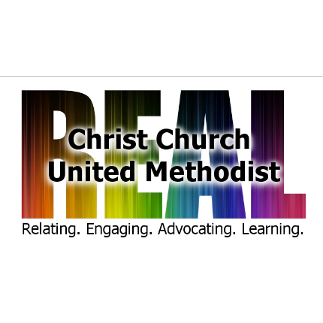

**Collaborative Musician/Accompanist**

**Christ United Methodist Denver, Colorado**

A progressive, reconciling church with a longstanding commitment to social justice, Christ United Methodist Church (CCUM) is seeking their next collaborative musician to accompany the choir, small ensembles and play special music during worship services. This part-time position is essential in creating music that complements worship. The collaborative musician’s primary focus is to work with the Director of Music during choir and ensemble rehearsals, the Sunday worship services and other special services as required. If you embrace all people, have a passion for a wide variety of music and the ability to effectively lead, teach, manage, and communicate with musicians then we want to hear from you.

**Responsibilities:**

* Be prepared for and assist in choir warmups and rehearsing service worship music as follows:
  + September through May: Weekly Wednesday evening rehearsals
  + June – August: Weekly rehearsals are for the hour and a half prior to the worship service
* Year round: Help warm up and accompany choir and ensembles on Sunday mornings prior to worship
* Accompany the choir for all anthems/service music during the service
* Special Service Responsibilities: Accompany musical presentations at additional services during Holy Week (Ash Wednesday, Maundy Thursday, Good Friday), Easter cantata and Advent/Christmas season

**Required Qualifications:**

* Demonstrate excellence at the keyboard
* Ability to play hymns, service music, and specials in a range of musical styles and difficulties
* Ability to follow flexible tempos from the Director of Music, soloists and small ensembles
* Ability to play the keyboard while sight-reading
* Ability to work collaboratively with others and encourage other musicians
* Possess good organizational and communication skills
* Familiarity with choral rehearsal approaches to support the Director of Music

**Preferred qualifications:**

* A bachelor’s degree in music with an emphasis in piano
* Two or three years of experience as a church pianist
* Ability to play the organ
* Ability to play an additional instrument
* Enthusiasm, positivity, creativity, and a good sense of humor.
* Excellent verbal and written communication skills are essential.

**Evaluation:**

* First three (3) months will be a probationary period with required weekly communication (either in person or by phone or email) with the Music Director.
* Annual evaluation will be conducted during the fall of each calendar year by the Music Director and a member of the Staff-Parish Relations Committee.

Terms of Employment:

* Compensation: commensurate with experience and role.
* Vacation days: 4 Sundays per year (prior approval by Pastor)
* Weekly hours:
  + September-May: 6:00 – 8:30 pm each Wednesday evening for choir practice (6:30-8:00 pm) and 9:30 am – noon each Sunday (choir rehearses at 10:00 am prior to service; service begins at 10:15 am)
  + June-August: 9:00-noon on Sunday mornings for a drop-in choir rehearsal 9:00-10:00
  + Practice time: suggest at least 2 hours per week

Application:

Send cover letter, resume, sample video or audio recordings and the contact information for 3 references to Rev. Emily Flemming  [pastor@christchurchcolorado.org](mailto:pastor@christchurchcolorado.org)